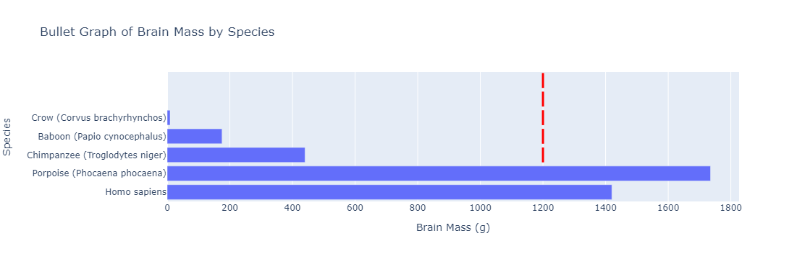**Bullet** **Graph**:

The species are displayed on yaxis and their corresponding brain masses are represented as horizontal bars on xaxis. Each species also has a red line at 1200-gram mark to visually indicate how their brain mass compares to this target value. This type of graph allows for a quick comparison to see which species have brain masses that are above, below or at target brain mass.

**Benchmark** **Graph**:

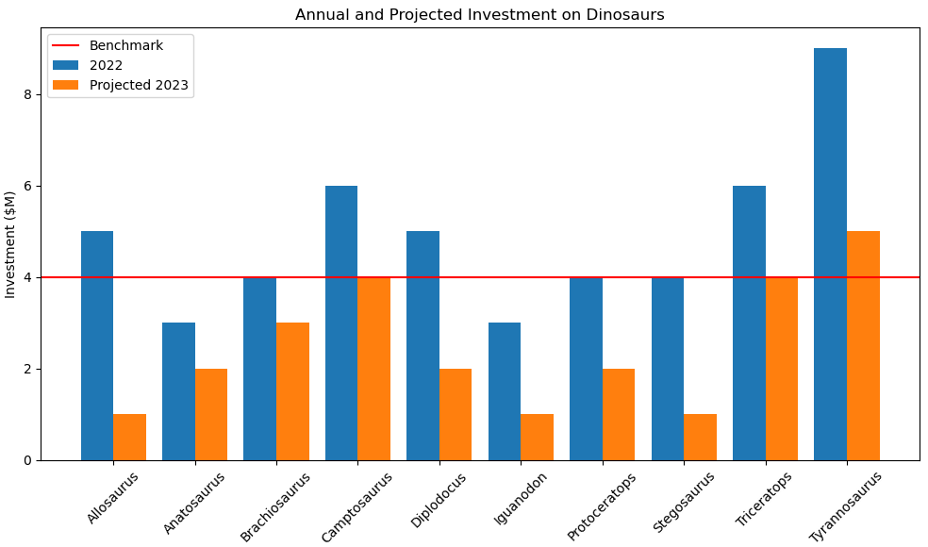

From this graph you can deduce which dinosaur genera have seen more or less investment in 2022 and how investment is expected to change in projections for 2023. You can also see how each of these figures compares to the benchmark level indicated by red line. For example, "Tyrannosaurus" has highest projected investment for 2023 which is significantly above benchmark.

**Tree Graph:**

The image displays a tree titled "Public Interest in Dinosaurs" which seems to measure level of interest in different types of dinosaurs based on a survey. The interest is scored on a scale from 1 to 5 with 5 being highest level of interest. The chart is organized by different dinosaur classifications such as Ornithopod, Sauropod, Ceratopsian, Stegosaur and Carnosaur.

**Heatmap:**

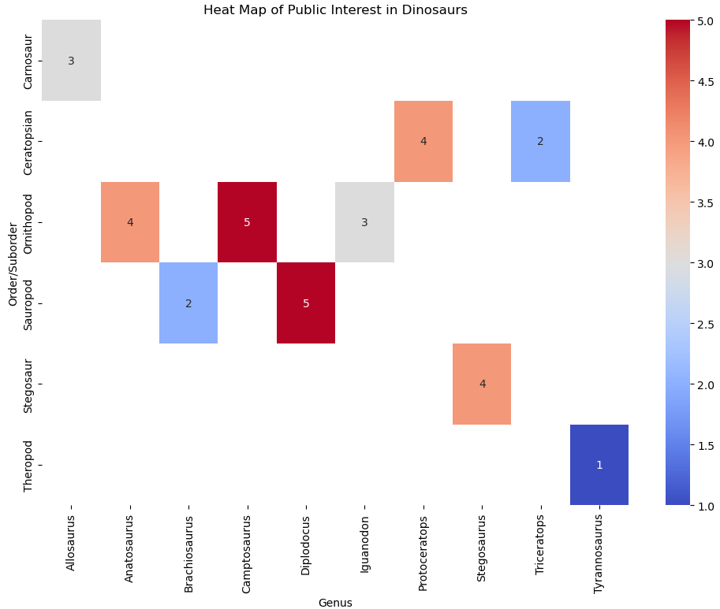

The heatmap titled Heat Map of Public Interest in Dinosaurs displays public interest levels in various dinosaur genera based on a survey interest scale from 1 to 5 with 5 indicating highest interest. Each cell on the heatmap corresponds to a different dinosaur genus and is colored based on the interest level with scale on the right indicating intensity of interest

**Sankey Diagram:**

The Sankey diagram illustrates stages of development for various dinosaur species from "Not Started" to "Embryo Development." Each species is linked to a stage indicating its progress in development process. However without variable widths in the bands to represent amount of progress or the number of individuals at each stage diagram primarily shows categorical status of each dinosaur's developmental stage rather than quantitative data.

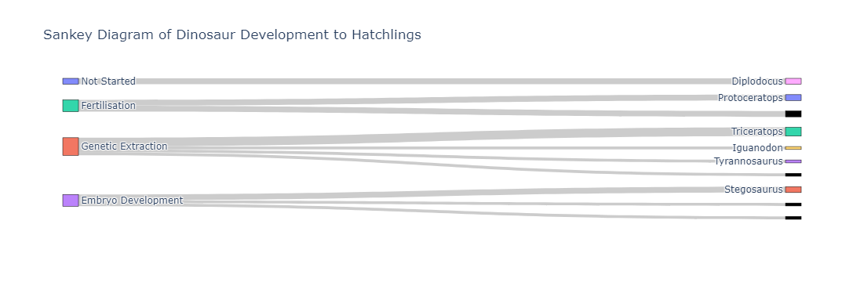

**Pie Chart:**

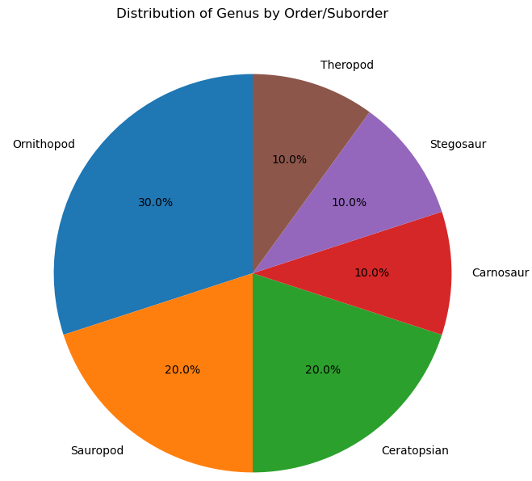

Ornithopod: 30%

Sauropod: 20%

Theropod: 10%

Stegosaur: 10%

Carnosaur: 10%

Ceratopsian: 20%

Ornithopods account for largest portion of chart at 30% indicating they make up highest percentage of genera in this distribution. Ceratopsians and Sauropods are equally represented at 20% followed by Theropods, Stegosaurs and Carnosaurs each at 10%. This chart helps to visualize relative diversity of dinosaur genera in each category

**Bar Chart:**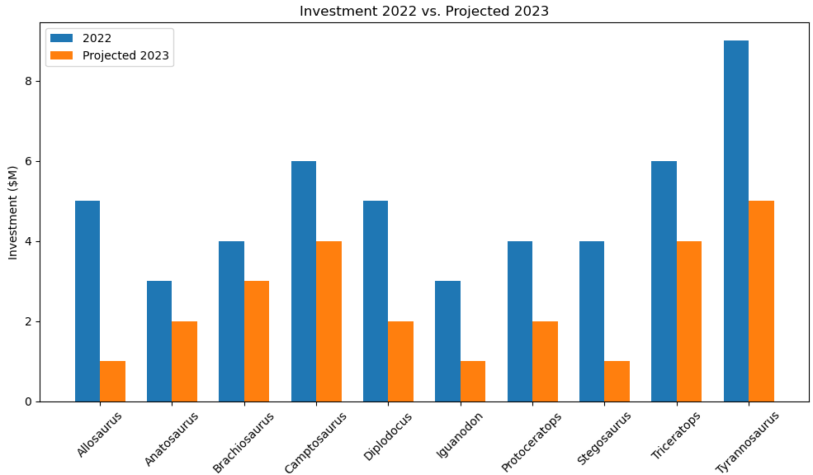

The pie chart you uploaded shows Distribution of Genus by Order/Suborde for different dinosaur groups. The chart is divided into slices that represent percentage of all the total

**Violin Plot:**

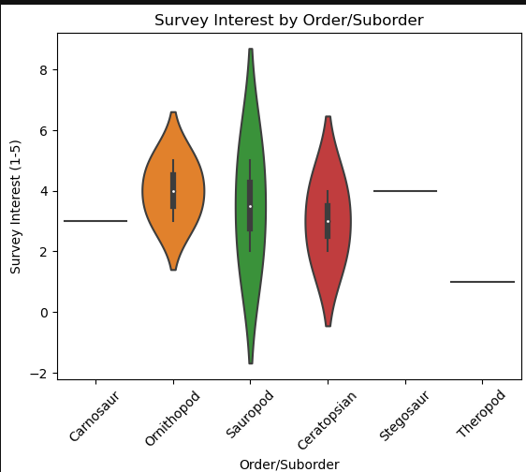

The plot is a visual representation of public interest in various dinosaur categories with each category having its own distribution of interest levels. It provides a sense of not only central tendency (like median interest) but also variability and density of interest levels within each dinosaur category. This type of plot can help identify which groups have a wider range of interest levels among survey respondents.

**Scatter Plot**:

The plot illustrates relationship between body and brain mass among various species or specimens. Most of data points are concentrated at lower end of body and brain mass with a few notable exceptions indicating species with disproportionately large brains for their body mass or extremely large body sizes.

**Box Plot:**

This plot is providing a comparison of projected investments for various dinosaur categories for 2023 highlighting the median, spread and range of projected amounts within each category. It is useful for quickly assessing central tendencies and variabilities of projected investments.

**Customer Journey Map:**

This visualization represents the journey stages from Awareness to Action for each dinosaur (Allosaurus, Anatosaurus, Brachiosaurus), with the interest levels serving as a proxy for customer engagement at each stage. The y-axis represents interest levels, with 1 indicating high interest and larger numbers indicating lower interest

